A transaction is a unit of work in which either all operations must execute or none of them. To understand the importance of the transaction, think of an example which applies to all of us. “Transferring Amount from one account to another “ – this operation includes below at least below two steps
- Deduct the balance from the sender’s account
- Add the amount to the receiver’s account.
Now think of the situation where the amount is deducted from the sender’s account, but not gets delivered to receiver account due to some errors. Such issues are managed by transaction management in which both the steps are performed in a single unit of work where either both steps are performed successfully or in case anyone gets failed, it should be roll backed.
The concept of transactions can be described with the following four key properties described as ACID −
- Atomicity − A transaction should be treated as a single unit of operation, which means either the entire sequence of operations is successful or unsuccessful.
- Consistency − This represents the consistency of the referential integrity of the database, unique primary keys in tables, etc.
- Isolation − There may be many transaction processing with the same data set at the same time. Each transaction should be isolated from others to prevent data corruption.
- Durability − Once a transaction has completed, the results of this transaction have to be made permanent and cannot be erased from the database due to system failure.
A real RDBMS database system will guarantee all four properties for each transaction. The simplistic view of a transaction issued to the database using SQL is as follows −
- Begin the transaction using begin transaction command.
- Perform various deleted, update or insert operations using SQL queries.
- If all the operation are successful then perform commit otherwise rollback all the operations.
Spring framework provides an abstract layer on top of different underlying transaction management APIs. Spring's transaction support aims to provide an alternative to EJB transactions by adding transaction capabilities to POJOs. Spring supports both programmatic and declarative transaction management. EJBs require an application server, but Spring transaction management can be implemented without the need of an application server.
- Choosing Transaction Manager:-

Instead of managing the transaction, Spring supports several transaction managers which delegate the transaction management responsibilities to platform specific implementations. Plarform Transaction manager is the parent of all transaction manager implementations.

Some of the transaction managers are-
- DataSource Transaction manager - We can use DataSourceTransactionManager for simple JDBC persistence mechanism. Sample configuration of DataSourceTransactionManager looks like below

<bean id=”transactionManager” class=”org.springframework.jdbc.datasource.DataSourceTransactionManager>
<property name=”dataSource” ref= “datasource” />
</bean>

- Hibernate Transaction manager – Hibernate transaction manager should be used when our application is using Hibernate. Sample configuration of HibernateTransactionManager looks like below

<bean id=”transactionManager”
class=”org.springframework.orm.hibernate3.HibernateTransactionManager>
<property name=”sessionFactory” ref= “sessionFactory” />
</bean>
- Jdo Transaction manager –Use below configuration to use Java data object transaction manager .

<bean id=”transactionManager”
class=”org.springframework.orm.jdo.JdoTransactionManager>
<property name=”persistanceManagerFactory” ref= “persistanceManagerFactory” />
</bean>
- Jta Transaction manager – If our transaction is across multiple data sources than we need to use Java Transactions API transactions . Internally JTA implementation handles transaction responsibility.

Use below configuration to configure JTA transaction manager.

<bean id=”transactionManager”
class=”org.springframework.transaction.jta.JtaTransactionManager>
<property name=”transactonManagerName” ref= “java:/TransactionManager” />
</bean>

Programmatic vs Declarative Transactions
Spring supports two types of transaction management −
- Programmatic transaction management − This means that you have to manage the transaction with the help of programming. That gives you extreme flexibility, but it is difficult to maintain.
- Declarative transaction management − This means you separate transaction management from the business code. You only use annotations or XML-based configuration to manage the transactions.

Spring provides platform independent Transaction manager API with the help of an abstract transaction management unit known as PlatformTransactionManager interface under org. springframework. transaction package.
public interface PlatformTransactionManager {
TransactionStatus getTransaction(TransactionDefinition definition);
throws TransactionException;
void commit(TransactionStatus status) throws TransactionException;
void rollback(TransactionStatus status) throws TransactionException;
}
Sr.No | Method & Description
1 | TransactionStatus getTransaction(TransactionDefinition definition) : This method returns a currently active transaction or creates a new one, according to the specified propagation behavior.
2 | void commit(TransactionStatus status) :This method commits the given transaction, with regard to its status.
3 | void rollback(TransactionStatus status) :This method performs a rollback of the given transaction.
The TransactionDefinition is the core interface of the transaction support in Spring and it is defined as follows −
public interface TransactionDefinition {
int getPropagationBehavior();
int getIsolationLevel();
String getName();
int getTimeout();
boolean isReadOnly(); }
Sr.No | Method & Description
1 | int getPropagationBehavior() :This method returns the propagation behavior. Spring offers all of the transaction propagation options familiar from EJB CMT.
2 | int getIsolationLevel() :This method returns the degree to which this transaction is isolated from the work of other transactions.
3 | String getName() : This method returns the name of this transaction.
4 | int getTimeout() : This method returns the time in seconds in which the transaction must complete.
5 | boolean isReadOnly() : This method returns whether the transaction is read-only.
Following are the possible values for isolation level −
Sr.No | Isolation & Description
1 | TransactionDefinition.ISOLATION_DEFAULT : This is the default isolation level.
2 | TransactionDefinition.ISOLATION_READ_COMMITTED :Indicates that dirty reads are prevented; non-repeatable reads and phantom reads can occur.
3 | TransactionDefinition.ISOLATION_READ_UNCOMMITTED :Indicates that dirty reads, non-repeatable reads, and phantom reads can occur.
4 | TransactionDefinition.ISOLATION_REPEATABLE_READ:Indicates that dirty reads and non-repeatable reads are prevented; phantom reads can occur.
5 | TransactionDefinition.ISOLATION_SERIALIZABLE:  Indicates that dirty reads, non-repeatable reads, and phantom reads are prevented.
Following are the possible values for propagation types −
Sr.No. | Propagation & Description
1 | TransactionDefinition.PROPAGATION_MANDATORY  Supports a current transaction; throws an exception if no current transaction exists.
2 | TransactionDefinition.PROPAGATION_NESTED  Executes within a nested transaction if a current transaction exists.
3 | TransactionDefinition.PROPAGATION_NEVER  Does not support a current transaction; throws an exception if a current transaction exists.
4 | TransactionDefinition.PROPAGATION_NOT_SUPPORTED  Does not support a current transaction; rather always execute nontransactionally.
5 | TransactionDefinition.PROPAGATION_REQUIRED  Supports a current transaction; creates a new one if none exists.
6 | TransactionDefinition.PROPAGATION_REQUIRES_NEW  Creates a new transaction, suspending the current transaction if one exists.
7 | TransactionDefinition.PROPAGATION_SUPPORTS  Supports a current transaction; executes non-transactionally if none exists.
8 | TransactionDefinition.TIMEOUT_DEFAULT  Uses the default timeout of the underlying transaction system, or none if timeouts are not supported.
The TransactionStatus interface provides a simple way for transactional code to control transaction execution and query transaction status.
public interface TransactionStatus extends SavepointManager {
boolean isNewTransaction();
boolean hasSavepoint();
void setRollbackOnly();
boolean isRollbackOnly();
boolean isCompleted();
}
Sr.No. | Method & Description
1 | boolean hasSavepoint()  This method returns whether this transaction internally carries a savepoint, i.e., has been created as nested transaction based on a savepoint.
2 | boolean isCompleted()  This method returns whether this transaction is completed, i.e., whether it has already been committed or rolled back.
3 | boolean isNewTransaction()  This method returns true in case the present transaction is new.
4 | boolean isRollbackOnly()  This method returns whether the transaction has been marked as rollback-only.
5 | void setRollbackOnly()  This method sets the transaction as rollback-only.

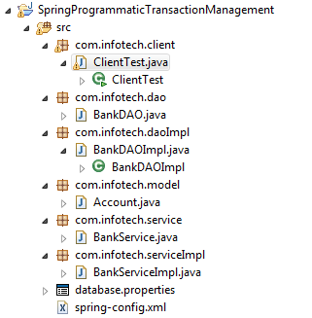
Jars Used:
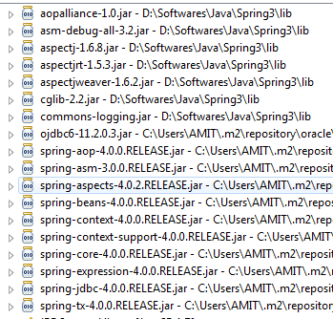

Database: Oracle
Table: ICICI_BANK
Table Structure:
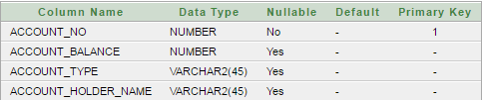
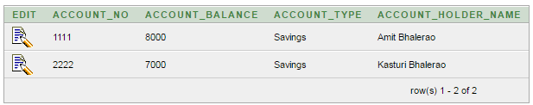

database .properties: Used to configure database properties
db.url=jdbc:oracle:thin:@localhost:1521:xe
db.drivername=oracle.jdbc.driver.OracleDriver
db.username=system
db.password=123456
spring-config.xml:
<?xml version="1.0" encoding="UTF-8"?>
<beans xmlns="http://www.springframework.org/schema/beans"
xmlns:xsi="http://www.w3.org/2001/XMLSchema-instance" xmlns:aop="http://www.springframework.org/schema/aop"
xmlns:context="http://www.springframework.org/schema/context" xmlns:tx="http://www.springframework.org/schema/tx"
xsi:schemaLocation="
http://www.springframework.org/schema/beans
http://www.springframework.org/schema/beans/spring-beans.xsd
http://www.springframework.org/schema/aop
http://www.springframework.org/schema/aop/spring-aop.xsd
http://www.springframework.org/schema/context
http://www.springframework.org/schema/context/spring-context.xsd
http://www.springframework.org/schema/tx
http://www.springframework.org/schema/tx/spring-tx.xsd">

<!--Load database.properties -->
<bean
class="org.springframework.context.support.PropertySourcesPlaceholderConfigurer">
<property name="location">
<value>database.properties</value>
</property>
</bean>

<!-- Create dataSource bean using database.properties -->
<bean id="dataSource"
class="org.springframework.jdbc.datasource.DriverManagerDataSource">
<property name="driverClassName" value="${db.drivername}"></property>
<property name="url" value="${db.url}"></property>
<property name="username" value="${db.username}"></property>
<property name="password" value="${db.password}"></property>
</bean>

<!-- Create transactionManager bean and Inject dataSource using setter injection-->
<bean id="transactionManager"
class="org.springframework.jdbc.datasource.DataSourceTransactionManager">
<property name="dataSource" ref="dataSource"></property>
</bean>

<!-- Create jdbcTemplate bean and Inject dataSource using setter injection-->
<bean id="jdbcTemplate" class="org.springframework.jdbc.core.JdbcTemplate">
<property name="dataSource" ref="dataSource"></property>
</bean>

<!-- Create bankDAO bean and Inject jdbcTemplate using setter injection-->
<bean id="bankDAO" class="com.infotech.daoImpl.BankDAOImpl">
<property name="jdbcTemplate" ref="jdbcTemplate"></property>
</bean>

<!-- Create transactionTemplate bean and Inject transactionManager using setter injection-->
<bean id="transactionTemplate"
class="org.springframework.transaction.support.TransactionTemplate">
<property name="transactionManager" ref="transactionManager"></property>
</bean>

<!-- Create bankService bean and Inject bankDAO and transactionTemplate using setter injection-->
<bean id="bankService" class="com.infotech.serviceImpl.BankServiceImpl">
<property name="bankDAO" ref="bankDAO"></property>
<property name="transactionTemplate" ref="transactionTemplate"></property>
</bean>
</beans>

Account.java:
package com.infotech.model;

public class Account {

private Integer accountNumber;
private Double accountBalance;
private String accounType;
private String accountHolderName;

public Integer getAccountNumber() {
return accountNumber;
}
public void setAccountNumber(Integer accountNumber) {
this.accountNumber = accountNumber;
}
public Double getAccountBalance() {
return accountBalance;
}
public void setAccountBalance(Double accountBalance) {
this.accountBalance = accountBalance;
}
public String getAccounType() {
return accounType;
}
public void setAccounType(String accounType) {
this.accounType = accounType;
}
public String getAccountHolderName() {
return accountHolderName;
}
public void setAccountHolderName(String accountHolderName) {
this.accountHolderName = accountHolderName;
}
}

BankDAO.java:
package com.infotech.dao;

import com.infotech.model.Account;

public interface BankDAO {

public abstract void withdraw(Account fromAccount,Double withdrawAmt);
public abstract void deposit(Account toAccount,Double depositAmt);
}

BankDAOImpl.java:
package com.infotech.daoImpl;

import org.springframework.jdbc.core.support.JdbcDaoSupport;
import com.infotech.dao.BankDAO;
import com.infotech.model.Account;

public class BankDAOImpl extends JdbcDaoSupport implements BankDAO {

@Override
public void withdraw(Account fromAccount, Double withdrawAmt) {
String sql="UPDATE icici_bank set account_balance=account_balance-"+withdrawAmt+" WHERE account_no=?";
int update = getJdbcTemplate().update(sql,fromAccount.getAccountNumber());
if(update>0)
System.out.println("Amount Rs:"+withdrawAmt+" is deducted from account:"+fromAccount.getAccountNumber());
}

@Override
public void deposit(Account toAccount, Double depositAmt) {
String sql="UPDATE icici_bank set account_balance=account_balance+"+depositAmt+" WHERE account_no=?";
int update = getJdbcTemplate().update(sql,toAccount.getAccountNumber());
if(update>0)
System.out.println("Amount Rs: "+depositAmt+" is deposited in Account:"+toAccount.getAccountNumber());
// throw new RuntimeException("");
}

}
BankService.java:
package com.infotech.service;

import com.infotech.model.Account;

public interface BankService {
public abstract void transferFund(Account fromAccount,Account toAccount,Double amount);
}

BankServiceImpl.java:

package com.infotech.serviceImpl;

import org.springframework.transaction.TransactionStatus;
import org.springframework.transaction.support.TransactionCallback;
import org.springframework.transaction.support.TransactionTemplate;
import com.infotech.dao.BankDAO;
import com.infotech.model.Account;
import com.infotech.service.BankService;

public class BankServiceImpl implements BankService {

private BankDAO bankDAO;
private TransactionTemplate transactionTemplate;

public void setTransactionTemplate(TransactionTemplate transactionTemplate) {
this.transactionTemplate = transactionTemplate;
}

public TransactionTemplate getTransactionTemplate() {
return transactionTemplate;
}

public void setBankDAO(BankDAO bankDAO) {
this.bankDAO = bankDAO;
}

public BankDAO getBankDAO() {
return bankDAO;
}
@Override
public void transferFund(final Account fromAccount, final Account toAccount, final Double amount) {
getTransactionTemplate().execute(new TransactionCallback<Void>() {

@Override
public Void doInTransaction(TransactionStatus paramTransactionStatus) {
getBankDAO().withdraw(fromAccount, amount);
getBankDAO().deposit(toAccount, amount);
return null;
}
});
}
}

ClientTest.java:
package com.infotech.client;

import org.springframework.context.support.AbstractApplicationContext;
import org.springframework.context.support.ClassPathXmlApplicationContext;
import com.infotech.model.Account;
import com.infotech.service.BankService;

public class ClientTest {
public static void main(String[] args) {
AbstractApplicationContext context=new ClassPathXmlApplicationContext("spring-config.xml");
BankService bankService = (BankService) context.getBean("bankService");
Account fromAccount=new Account();
fromAccount.setAccountNumber(1111);
Account toAccount=new Account();
toAccount.setAccountNumber(2222);
bankService.transferFund(fromAccount, toAccount, 1000.00);
context.close();
}
}

- Save all the java files
- Run ClientTest.java as Java Application
- Positive Scenario:
Console Logs:
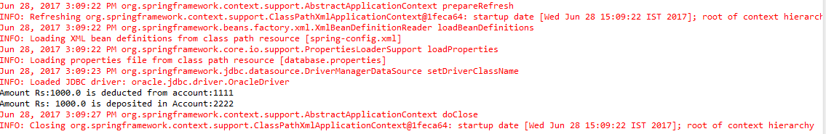
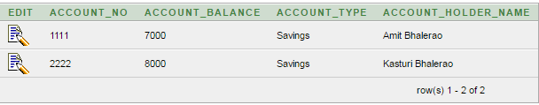

- Negative Scenario:
Uncomment below code from BankDAOImpl.java and Run ClientTest.java as Java Application
throw new RuntimeException ("");
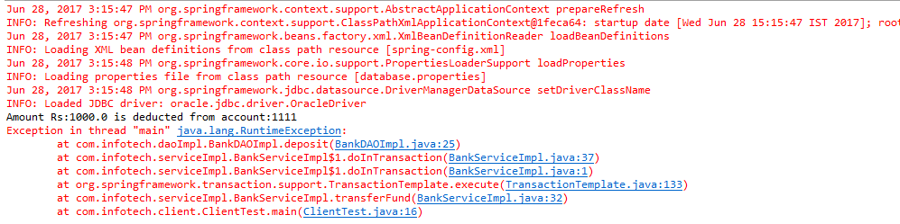
In this case Exception is occurred after the amount is got deducted from account no : 1111 so this transaction should get rolled back.
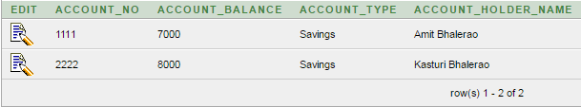

TransactionDefinition def = new DefaultTransactionDefinition();
TransactionStatus status = transactionManager.getTransaction(def);

try {
String SQL1 = "insert into Student (name, age) values (?, ?)";
jdbcTemplateObject.update(SQL1, name, age);

// Get the latest student id to be used in Marks table
String SQL2 = "select max(id) from Student";
int sid = jdbcTemplateObject.queryForInt(SQL2);

String SQL3 = "insert into Marks(sid, marks, year) "
+ "values (?, ?, ?)";
jdbcTemplateObject.update(SQL3, sid, marks, year);

System.out.println("Created Name = " + name + ", Age = " + age);
transactionManager.commit(status);
}
catch (DataAccessException e)
{
System.out.println("Error in creating record, rolling back");
transactionManager.rollback(status);
throw e;
}
Here we are following below steps
  - Insert the data into Student table
  - Fetch sid=max(id) from Student table
  - Using sid from step 2) insert data into StudentMarks table
If any exception occurs
- After inserting the data into Student table and before inserting data into the StudentMarks table
- After inserting the data into Student and StudentMarks tables
Then the transaction will be rolled back else it will be committed.

Declarative transaction management approach allows you to manage the transaction with the help of configuration instead of hard coding in your source code. This means that you can separate transaction management from the business code. You only use annotations or XML-based configuration to manage the transactions. The bean configuration will specify the methods to be transactional

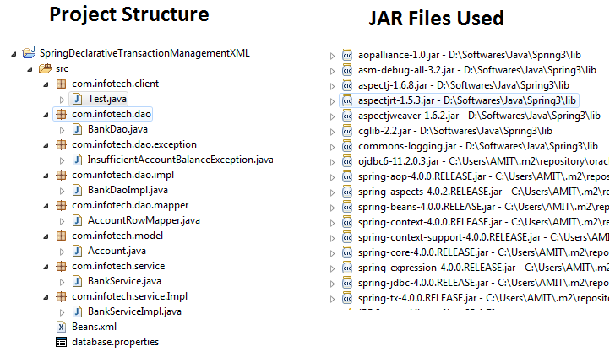
Database: Oracle
Table: ICICI_BANK
Table Structure:
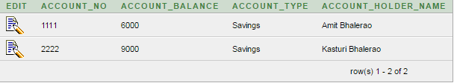
database .properties: Used to configure database properties
db.url=jdbc:oracle:thin:@localhost:1521:xe
db.drivername=oracle.jdbc.driver.OracleDriver
db.username=system
db.password=123456
Beans.xml:
<?xml version="1.0" encoding="UTF-8"?>
<beans xmlns="http://www.springframework.org/schema/beans"
xmlns:xsi="http://www.w3.org/2001/XMLSchema-instance" xmlns:aop="http://www.springframework.org/schema/aop"
xmlns:context="http://www.springframework.org/schema/context" xmlns:tx="http://www.springframework.org/schema/tx"
xsi:schemaLocation="
http://www.springframework.org/schema/beans
http://www.springframework.org/schema/beans/spring-beans.xsd
http://www.springframework.org/schema/aop
http://www.springframework.org/schema/aop/spring-aop.xsd
http://www.springframework.org/schema/context
http://www.springframework.org/schema/context/spring-context.xsd
http://www.springframework.org/schema/tx
http://www.springframework.org/schema/tx/spring-tx.xsd">

<!-- Load database.properties -->
<bean
class="org.springframework.beans.factory.config.PropertyPlaceholderConfigurer">
<property name="location">
<value>database.properties</value>
</property>
</bean>

<!-- Create dataSource bean using database.properties -->
<bean id="dataSource"
class="org.springframework.jdbc.datasource.DriverManagerDataSource">
<property name="driverClassName" value="${db.drivername}"></property>
<property name="url" value="${db.url}"></property>
<property name="username" value="${db.username}"></property>
<property name="password" value="${db.password}"></property>
</bean>

<!-- Create a AOP Advice -->
<tx:advice id="transactionAdvice">
<tx:attributes>
<tx:method name="transferFund" isolation="READ_COMMITTED"
read-only="false" propagation="REQUIRED" timeout="100"
rollback-for="java.lang.Exception" />
</tx:attributes>
</tx:advice>

<!-- Configure AOP with Advice Created -->
<aop:config proxy-target-class="true">
<aop:advisor advice-ref="transactionAdvice"
pointcut="execution(* com.infotech.service.Impl.BankServiceImpl.transfer*(..))" />
</aop:config>

<!-- -->
<bean id="transactionManager"
class="org.springframework.jdbc.datasource.DataSourceTransactionManager">
<constructor-arg name="dataSource" ref="dataSource"></constructor-arg>
</bean>

<bean id="jdbcTemplate" class="org.springframework.jdbc.core.JdbcTemplate">
<constructor-arg name="dataSource" ref="dataSource"></constructor-arg>
</bean>

<bean id="bankDao" class="com.infotech.dao.impl.BankDaoImpl">
<property name="jdbcTemplate" ref="jdbcTemplate"></property>
</bean>

<bean id="bankService" class="com.infotech.service.Impl.BankServiceImpl">
<property name="bankDao" ref="bankDao"></property>
</bean>
</beans>

- AOP use tx:advice that ensure that any operation defined in the BankDao interface are transactional.
- <aop:config/> definition confirms that transactional advice defined using ‘txAdvice’ bean will executes at appropriate points in program. First thing we have defined pointcut which matches execution of any operation(expression=”execution(*com.infotech.service.Impl.BankServiceImpl.transfer*(..))”/> defined in the BankDao interface. We have associated pointcut with ‘txAdvice’ using an advisor with pointcut-ref indicates that execution of ‘BankDao’ and advice defined by’txAdvice’ will be run.

Account.java:
package com.infotech.model;

public class Account {

private Long accountNumber;
private String accountType;
private Double accountBalance;
private String accountHolderName;

public Long getAccountNumber() {
return accountNumber;
}
public void setAccountNumber(Long accountNumber) {
this.accountNumber = accountNumber;
}
public String getAccountType() {
return accountType;
}
public void setAccountType(String accountType) {
this.accountType = accountType;
}
public Double getAccountBalance() {
return accountBalance;
}
public void setAccountBalance(Double accountBalance) {
this.accountBalance = accountBalance;
}
public String getAccountHolderName() {
return accountHolderName;
}
public void setAccountHolderName(String accountHolderName) {
this.accountHolderName = accountHolderName;
}
}

BankDao.java:
package com.infotech.dao;

import com.infotech.dao.exception.InsufficientAccountBalanceException;
import com.infotech.model.Account;

public interface BankDao {
public abstract void withdraw(Account fromAccount,Account toAccount,Double amount) throws InsufficientAccountBalanceException;
public abstract void deposit(Account fromAccount,Account toAccount,Double amount);
}

BankDaoImpl.java:

package com.infotech.dao.impl;
import org.springframework.jdbc.core.JdbcTemplate;
import com.infotech.dao.BankDao;
import com.infotech.dao.exception.InsufficientAccountBalanceException;
import com.infotech.dao.mapper.AccountRowMapper;
import com.infotech.model.Account;

public class BankDaoImpl implements BankDao {
private JdbcTemplate jdbcTemplate;

public JdbcTemplate getJdbcTemplate() {
return jdbcTemplate;
}
public void setJdbcTemplate(JdbcTemplate jdbcTemplate) { this.jdbcTemplate = jdbcTemplate;
}

public void withdraw(Account fromAccount, Account toAccount, Double amount) throws InsufficientAccountBalanceException {
Account accountFromDb = getAccountFromDb(fromAccount.getAccountNumber());

Double accountBalance = accountFromDb.getAccountBalance()-amount;
if(accountFromDb.getAccountBalance()>=amount){
String SQL="UPDATE icici_bank set account_balance=? WHERE account_no=?";
int update = getJdbcTemplate().update(SQL, accountBalance,fromAccount.getAccountNumber());
if(update>0){
System.out.println("Amount Rs:"+amount+" is tranferred from Account No:"+fromAccount.getAccountNumber() +" to Account No:"+toAccount.getAccountNumber());
}
}else{
throw new InsufficientAccountBalanceException("Insufficient account balance");
}
}

public void deposit(Account fromAccount, Account toAccount, Double amount) {
Account accountFromDb = getAccountFromDb(toAccount.getAccountNumber());
Double accountBalance = accountFromDb.getAccountBalance()+amount;
String SQL="UPDATE icici_bank set account_balance=? WHERE account_no=?";
int update = getJdbcTemplate().update(SQL, accountBalance,toAccount.getAccountNumber());
if(update>0){
System.out.println("Amount Rs:"+amount+" is deposited in Account No:"+toAccount.getAccountNumber());
//throw new RuntimeException();
}
}

private Account getAccountFromDb(Long accountNumber) {
String SQL ="SELECT * FROM icici_bank WHERE account_no = ?";
Account account = getJdbcTemplate().queryForObject(SQL,new AccountRowMapper(), accountNumber);
return account;
}
}
BankService.java:
package com.infotech.service;

import com.infotech.dao.exception.InsufficientAccountBalanceException;
import com.infotech.model.Account;

public interface BankService {
public abstract void transferFund(Account fromAccount,Account toAccount,Double amount)throws InsufficientAccountBalanceException;
}

BankServiceImpl.java:
package com.infotech.service.Impl;

import com.infotech.dao.BankDao;
import com.infotech.dao.exception.InsufficientAccountBalanceException;
import com.infotech.model.Account;
import com.infotech.service.BankService;

public class BankServiceImpl implements BankService {

private BankDao bankDao;

public void setBankDao(BankDao bankDao) {
this.bankDao = bankDao;
}

public BankDao getBankDao() {
return bankDao;
}

public void transferFund(Account fromAccount, Account toAccount,
Double amount) throws InsufficientAccountBalanceException {
getBankDao().withdraw(fromAccount, toAccount, amount);
getBankDao().deposit(fromAccount, toAccount, amount);
}
}

Test.java:
package com.infotech.client;

import org.springframework.context.support.AbstractApplicationContext;
import org.springframework.context.support.ClassPathXmlApplicationContext;
import com.infotech.dao.exception.InsufficientAccountBalanceException;
import com.infotech.model.Account;
import com.infotech.service.BankService;
import com.infotech.service.Impl.BankServiceImpl;

public class Test {
public static void main(String[] args) {

AbstractApplicationContext ctx = new ClassPathXmlApplicationContext("Beans.xml");
BankService bankService = ctx.getBean("bankService", BankServiceImpl.class);
Account fromAccount = new Account();
fromAccount.setAccountNumber(1111L);
Account toAccount = new Account();
toAccount.setAccountNumber(2222L);

try {
bankService.transferFund(fromAccount, toAccount, 1000.00);
} catch (InsufficientAccountBalanceException e) {
e.printStackTrace();
}
ctx.close();
}
}

- Save all the java files
- Run ClientTest.java as Java Application
1) Positive Scenario:
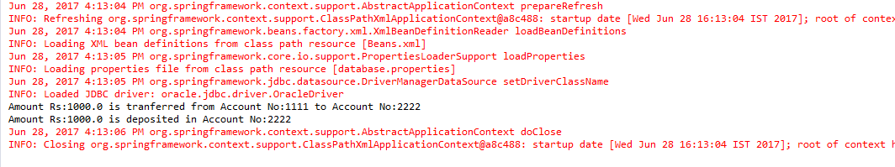
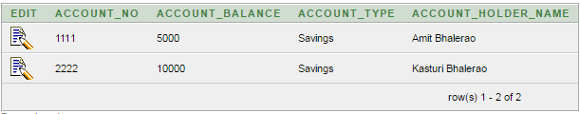
2) Negative Scenario:
Uncomment below code from BankDAOImpl.java and Run ClientTest.java as Java Application
throw new RuntimeException ("");
In this case Exception is occurred after the amount is got deducted from account no : 1111 so this transaction should get rolled back.

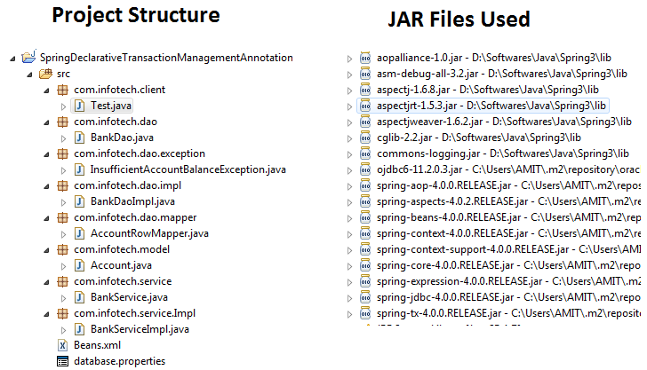
Database: Oracle
Table: ICICI_BANK
Table Structure:
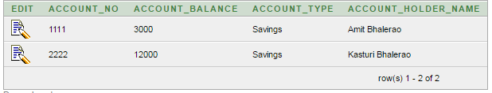
database .properties: Used to configure database properties
db.url=jdbc:oracle:thin:@localhost:1521:xe
db.drivername=oracle.jdbc.driver.OracleDriver
db.username=system
db.password=123456

Beans.xml:
<?xml version="1.0" encoding="UTF-8"?>
<beans xmlns="http://www.springframework.org/schema/beans"
xmlns:xsi="http://www.w3.org/2001/XMLSchema-instance" xmlns:aop="http://www.springframework.org/schema/aop"
xmlns:context="http://www.springframework.org/schema/context" xmlns:tx="http://www.springframework.org/schema/tx"
xsi:schemaLocation="
http://www.springframework.org/schema/beans
http://www.springframework.org/schema/beans/spring-beans.xsd
http://www.springframework.org/schema/aop
http://www.springframework.org/schema/aop/spring-aop.xsd
http://www.springframework.org/schema/context
http://www.springframework.org/schema/context/spring-context.xsd
http://www.springframework.org/schema/tx
http://www.springframework.org/schema/tx/spring-tx.xsd">

<context:annotation-config/>
<tx:annotation-driven transaction-manager="transactionManager" proxy-target-class="true"/>

<bean id="transactionManager" class="org.springframework.jdbc.datasource.DataSourceTransactionManager">
<constructor-arg name="dataSource" ref="dataSource"></constructor-arg>
</bean>

<bean class="org.springframework.beans.factory.config.PropertyPlaceholderConfigurer">
<property name="location">
<value>database.properties</value>
</property>
</bean>

<bean id="dataSource"
class="org.springframework.jdbc.datasource.DriverManagerDataSource">
<property name="driverClassName" value="${db.drivername}"></property>
<property name="url" value="${db.url}"></property>
<property name="username" value="${db.username}"></property>
<property name="password" value="${db.password}"></property>
</bean>

<bean id="jdbcTemplate" class="org.springframework.jdbc.core.JdbcTemplate">
<constructor-arg name="dataSource" ref="dataSource"></constructor-arg>
</bean>

<bean id="bankDao" class="com.infotech.dao.impl.BankDaoImpl">
<property name="jdbcTemplate" ref="jdbcTemplate"></property>
</bean>

<bean id="bankService" class="com.infotech.service.Impl.BankServiceImpl">
<property name="bankDao" ref="bankDao"></property>
</bean>

</beans>
- we are activating annotation based transaction context by using <context:annotation-config/>
- tx:annotation-driven: This adds transactional scope and wraps transaction support to all code wherever @transaction defined on class level
- transactionManager : Heart of transaction: PlatformTransactionManager which are going to drive transaction
- dataSource : Data base and its property configuration
- jdbcTemplate : We are using JdbcTemplate to execute query This configuration will activate JdbcTemplate API and will be available to use in our code.

- Inject jdbcTemplate into DAO
- Inject DAO into Service

Account.java:
package com.infotech.model;

public class Account {

private Long accountNumber;
private String accountType;
private Double accountBalance;
private String accountHolderName;

public Long getAccountNumber() {
return accountNumber;
}
public void setAccountNumber(Long accountNumber) {
this.accountNumber = accountNumber;
}
public String getAccountType() {
return accountType;
}
public void setAccountType(String accountType) {
this.accountType = accountType;
}
public Double getAccountBalance() {
return accountBalance;
}
public void setAccountBalance(Double accountBalance) {
this.accountBalance = accountBalance;
}
public String getAccountHolderName() {
return accountHolderName;
}
public void setAccountHolderName(String accountHolderName) {
this.accountHolderName = accountHolderName;
}
}

BankDao.java:
package com.infotech.dao;

import com.infotech.dao.exception.InsufficientAccountBalanceException;
import com.infotech.model.Account;

public interface BankDao {
public abstract void withdraw(Account fromAccount,Account toAccount,Double amount) throws InsufficientAccountBalanceException;
public abstract void deposit(Account fromAccount,Account toAccount,Double amount);
}

BankDaoImpl.java:

package com.infotech.dao.impl;
import org.springframework.jdbc.core.JdbcTemplate;
import com.infotech.dao.BankDao;
import com.infotech.dao.exception.InsufficientAccountBalanceException;
import com.infotech.dao.mapper.AccountRowMapper;
import com.infotech.model.Account;

public class BankDaoImpl implements BankDao {
private JdbcTemplate jdbcTemplate;

public JdbcTemplate getJdbcTemplate() {
return jdbcTemplate;
}
public void setJdbcTemplate(JdbcTemplate jdbcTemplate) { this.jdbcTemplate = jdbcTemplate;
}

public void withdraw(Account fromAccount, Account toAccount, Double amount) throws InsufficientAccountBalanceException {
Account accountFromDb = getAccountFromDb(fromAccount.getAccountNumber());

Double accountBalance = accountFromDb.getAccountBalance()-amount;
if(accountFromDb.getAccountBalance()>=amount){
String SQL="UPDATE icici_bank set account_balance=? WHERE account_no=?";
int update = getJdbcTemplate().update(SQL, accountBalance,fromAccount.getAccountNumber());
if(update>0){
System.out.println("Amount Rs:"+amount+" is tranferred from Account No:"+fromAccount.getAccountNumber() +" to Account No:"+toAccount.getAccountNumber());
}
}else{
throw new InsufficientAccountBalanceException("Insufficient account balance");
}
}

public void deposit(Account fromAccount, Account toAccount, Double amount) {
Account accountFromDb = getAccountFromDb(toAccount.getAccountNumber());
Double accountBalance = accountFromDb.getAccountBalance()+amount;
String SQL="UPDATE icici_bank set account_balance=? WHERE account_no=?";
int update = getJdbcTemplate().update(SQL, accountBalance,toAccount.getAccountNumber());
if(update>0){
System.out.println("Amount Rs:"+amount+" is deposited in Account No:"+toAccount.getAccountNumber());
//throw new RuntimeException();
}
}

private Account getAccountFromDb(Long accountNumber) {
String SQL ="SELECT * FROM icici_bank WHERE account_no = ?";
Account account = getJdbcTemplate().queryForObject(SQL,new AccountRowMapper(), accountNumber);
return account;
}
}
BankService.java:
package com.infotech.service;

import com.infotech.dao.exception.InsufficientAccountBalanceException;
import com.infotech.model.Account;

public interface BankService {
public abstract void transferFund(Account fromAccount,Account toAccount,Double amount)throws InsufficientAccountBalanceException;
}

BankServiceImpl.java:
package com.infotech.service.Impl;

import com.infotech.dao.BankDao;
import com.infotech.dao.exception.InsufficientAccountBalanceException;
import com.infotech.model.Account;
import com.infotech.service.BankService;

public class BankServiceImpl implements BankService {

private BankDao bankDao;

public void setBankDao(BankDao bankDao) {
this.bankDao = bankDao;
}

public BankDao getBankDao() {
return bankDao;
}

@Transactional(isolation = Isolation.READ_COMMITTED, propagation = Propagation.REQUIRED, readOnly = false, timeout = 100, rollbackFor = Exception.class)
public void transferFund(Account fromAccount, Account toAccount,
Double amount) throws InsufficientAccountBalanceException {
getBankDao().withdraw(fromAccount, toAccount, amount);
getBankDao().deposit(fromAccount, toAccount, amount);
}
}

Test.java:
package com.infotech.client;

import org.springframework.context.support.AbstractApplicationContext;
import org.springframework.context.support.ClassPathXmlApplicationContext;
import com.infotech.dao.exception.InsufficientAccountBalanceException;
import com.infotech.model.Account;
import com.infotech.service.BankService;
import com.infotech.service.Impl.BankServiceImpl;

public class Test {
public static void main(String[] args) {

AbstractApplicationContext ctx = new ClassPathXmlApplicationContext("Beans.xml");
BankService bankService = ctx.getBean("bankService", BankServiceImpl.class);
Account fromAccount = new Account();
fromAccount.setAccountNumber(1111L);
Account toAccount = new Account();
toAccount.setAccountNumber(2222L);

try {
bankService.transferFund(fromAccount, toAccount, 1000.00);
} catch (InsufficientAccountBalanceException e) {
e.printStackTrace();
}
ctx.close();
}
}

- Save all the java files
- Run ClientTest.java as Java Application
1) Positive Scenario:

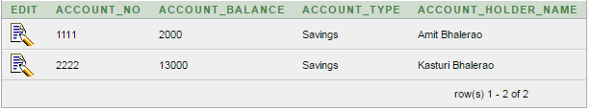
2) Negative Scenario:
Uncomment below code from BankDAOImpl.java and Run ClientTest.java as Java Application
throw new RuntimeException ("");
In this case Exception is occurred after the amount is got deducted from account no : 1111 so this transaction should get rolled back.

Spring Transaction Attributes
Spring transactions allow setting up the propagation behavior, isolation, timeout and read only settings of a transaction. Before we delve into the details, here are some points that need to be kept in mind
- Isolation level and timeout settings get applied only after the transaction starts.
- Not all transaction managers specify all values and may throw exception with some non default values
Propagation :
PROPAGATION_REQUIRED
This attribute tells that the code needs to be run in a transactional context. If a transaction already exists then the code will use it otherwise a new transaction is created. This is the default and mostly widely used transaction setting.
PROPAGATION_SUPPORTS
If a transaction exists then the code will use it, but the code does not require a new one. As an example, consider a ticket reservation system. A query to get total seats available can be executed non-transactionally. However, if used within a transaction context it will deduct tickets already selected and reduce them from the total count, and hence may give a better picture. This attribute should be used with care especially when PROPAGATION_REQUIRED or PROPAGATION_REQUIRES_NEW is used within a PROPAGATION_SUPPORTS context.
PROPAGATION_MANDATORY
Participates in an existing transaction, however if no transaction context is present then it throws a TransactionRequiredException
PROPAGATION_REQUIRES_NEW
Creates a new transaction and if an existing transaction is present then it is suspended. In other words a new transaction is always started. When the new transaction is complete then the original transaction resumes. This transaction type is useful when a sub activity needs to be completed irrespective of the containing transaction. The best example of this is logging. Even if a transaction roll backs you still want to preserve the log statements. Transaction suspension may not work out of the box with all transaction managers, so make sure that the transaction manager supports transaction suspension
PROPAGATION_NOT_SUPPORTED
This attribute says that transaction is not supported. In other words the activity needs to be performed non-transactionally. If an existing transaction is present then it is suspended till the activity finishes.
PROPAGATION_NEVER
This attributes says that the code cannot be invoked within a transaction. However, unlike PROPAGATION_NOT_SUPPORTED, if an existing transaction is present then an exception will be thrown
PROPAGATION_NESTED
The code is executed within a nested transaction if existing transaction is present, if no transaction is present then a new transaction is created. Nested transaction is supported out of the box on only certain transaction managers.
Isolation :
Isolation is a property of a transaction that determines what effect a transaction has on other concurrent transactions. To completely isolate the transaction the database may apply locks to rows or tables. Before we go through the transaction levels, let us look at some problems that occur when transaction 1 reads data that is being modified by transaction 2.
- Dirty Reads– Dirty reads occur when transaction 2 reads data that has been modified by transaction 1 but not committed. The problem occurs when transaction 1 rollbacks the transaction, in which case the data read by transaction 2 will be invalid.
- Non Repeatable Reads– Nonrepeatable reads happen when a transaction fires the same query multiple times but receives different data each time for the same query. This may happen when another transaction has modified the rows while this query is in progress.
- Phantom Reads – Phantom reads occur when the collection of rows returned is different when a same query is executed multiple times in a transaction. Phantom reads occur when transaction 2 adds rows to a table between the multiple queries of transaction 1.
The following isolation levels are supported by spring
ISOLATION_DEFAULT
Use the isolation level of the underlying database.
ISOLATION_READ_UNCOMMITTED
This is the lowest level of isolation and says that a transaction is allowed to read rows that have been added but not committed by another transaction. This level allows dirty reads, phantom reads and non repeatable reads.
ISOLATION_READ_COMMITTED
This level allows multiple transactions on the same data but does not allow uncommited transaction of one transaction to be read by another. This level, therefore, prevents dirty reads but allows phantom reads and nonrepeatable reads. This is the default isolation setting for most database and is supported by most databases.
ISOLATION_REPEATABLE_READ
This level ensures that the data set read during a transaction remains constant even if another transaction modifies and commits changes to the data. Therefore if transaction 1 reads 4 rows of data and transaction 2 modifies and commits the fourth row and then transaction 1 reads the four rows again then it does not see the modifications made by transaction 2. (It does not see the changes made in the fourth row by the second transaction). This level prevents dirty reads and non repeatable reads but allows phantom reads.
ISOLATION_SERIALIZABLE
This is the highest isolation level. It prevents dirty reads, non repeatable reads and phantom reads. This level prevents the situation when transaction 1 performs a query with a certain where clause and retrieves say four rows, transaction 2 inserts a row that forms part of the same where clause and then transaction 1 reruns the query with the same where clause but still sees only four rows (does not see the row added by the second transaction)
Read Only:
The read only attribute specifies that the transaction is only going to read data from a database. The advantage is that the database may apply certain optimization to the transaction when it is declared to be read only. Since read only attribute comes in action as soon as the transaction starts, it may be applied to only those propagation settings that start a transaction. i.e. PROPAGATION_REQUIRED,PROPAGATION_REQUIRES_NEW and PROPAGATION_NESTED.
Timeout:
Timeout specifies the maximum time allowed for a transaction to run. This may be required since transactions that run for a very long time may unnecessarily hold locks for a long time. When a transaction reaches the timeout period, it is rolled back. Timeout needs to be specified only on propagation settings that start a new transaction
Rollback Rules:
It is also possible to specify that transactions roll back on certain exceptions and do not rollback on other exceptions by specifying the rollback rules.

